User Manual

1)Registration

1. If the user does not have an account with the website, they’re prompted to make a new account

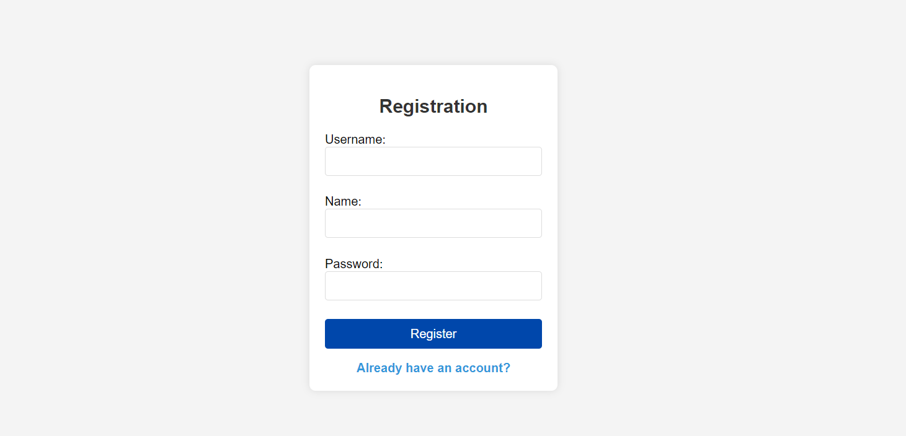

2) Login

1. Once the Registration has been completed, the user is prompted towards a login page so that they’re able ot access their account

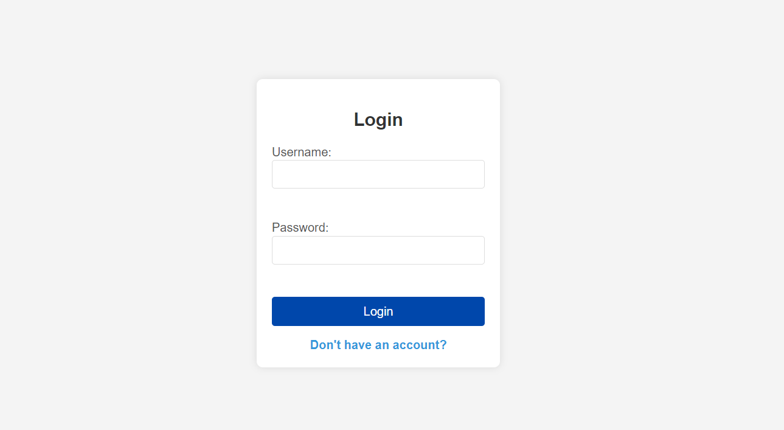

3) Home page

1. Once the user is logged in to their account on the **home** page their able to see a list of the courses that theyre **currently enrolled in** and they can see a list of the courses that **have been completed**

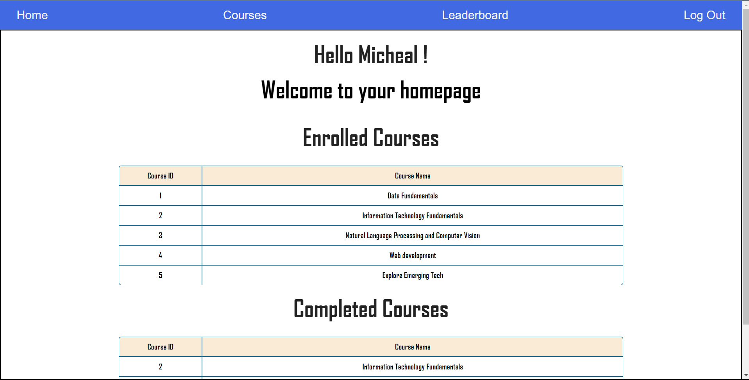

4) Viewing Courses

* From the given list of courses the user is provided with a number of options namely:
* **Start Course –** this button starts a timer once the user clicks on it to effectively track the time taken for the user to complete the course
* **Pause/Resume Course –** These buttons provide the user with the functionality to stop and resume the timer anytime they want
* **Complete Course –** This button allows the user to mark their course as complete

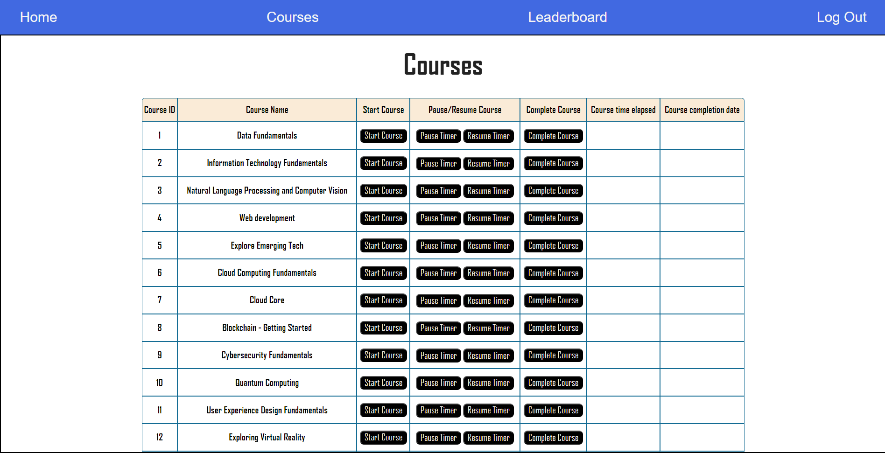

5) Leaderboard

* Upon clicking on the leaderboard the user is sent to the global leaderboard which shows a list of other users and their achievements, the top 10 users are granted a badge and the color of the badge varies according to the position of the user
* Golden – For the First place
* Gray – For the Second place
* Brown – For the Third place
* Purple – For the Fourth position
* Green – For the Fifth position
* Blue – For The Last position

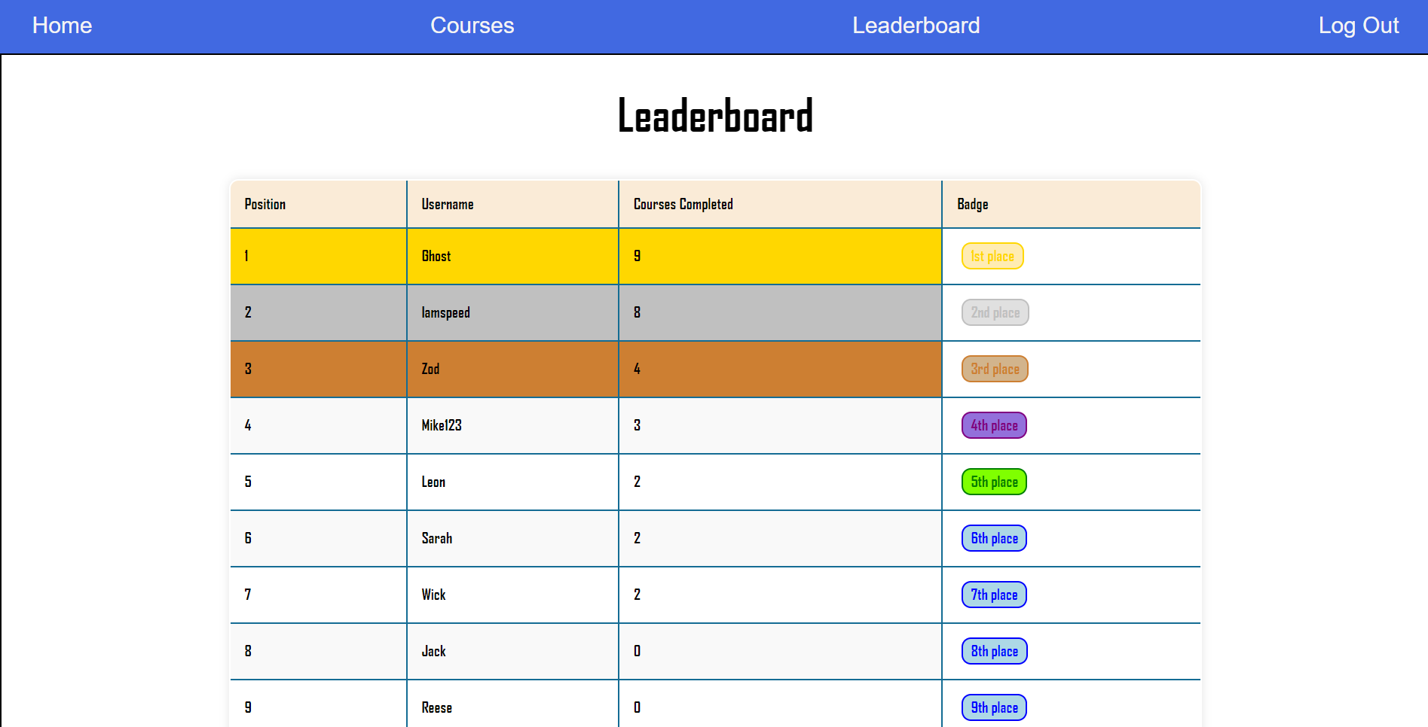

6) Logout

* The logout button in the top right allows the user to log out and once the logout button has been clicked the user is taken back to the login page

